Assignment 10

Name – Abhishek Agrahari

Roll Number 190123066

Question 1

Taking ti = i/5000 generated W(t) for time interval [0,1] from the following formula-

$$W\left(t_{i+1}\right)=W\left(t_{i}\right)+\sqrt{t_{i+1}-t_{i}}{ Z}_{i+1}$$

where Zi are independent standard normal N(0,1) and W (0) = 0

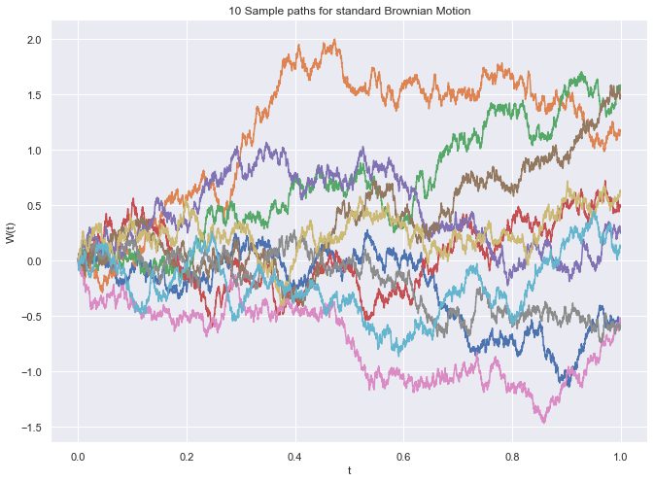

Question 2

(a) Using simple monte carlo –

Because there were no points which are greater than 4 therefore simple monte carlo was unable to capture the actual distribution.

P(X > 4) = 0

Standard Error = 0

CI = [0,0]

(b) Using importance sampling –

I generated from N(4,1).

q(X) = PDF_Of_Normal(4,1)

p(X) = PDF_Of_Normal(0,1)

f(X) = I(X > 4)

h(X) = f(X)*p(X)/q(X), where X is N(4,1)

imp =

P(X > 4) = 1.6303722361504857e-05

Standard Error = 3.4200776836168436e-05

CI = [3.1453817866343184e-05,3.145985348292596e-05]

Variance = 1.1696931361973954e-09

(c) On calculating variance by importance sampling variance is increased to 1.1696931361973954e-09 from 0 in simple monte carlo.

On running the same code Confidence interval of the simple monte carlo changes more rapidly than importance sampling. This is because barely 1 point came out 10,000 points which is greater than 4. Therefore results from simple monte carlo are not reliable.

Question 3

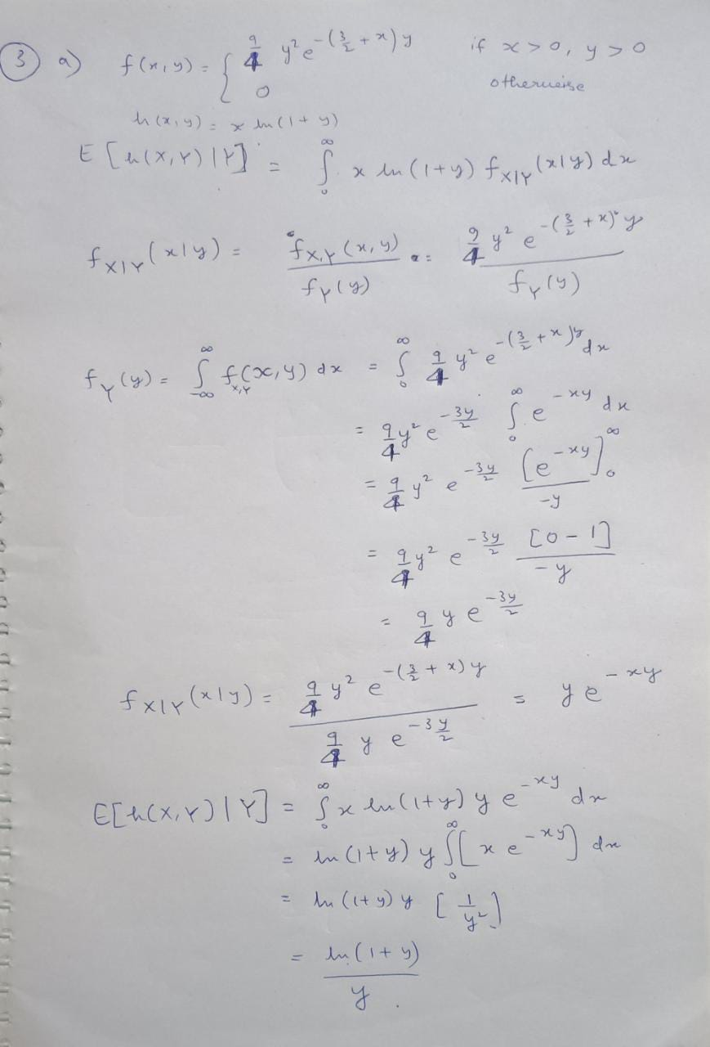

Distribution of y is Gamma(α= 2, β = 1.5)

Gamma(α, β) can be generated by following algorithms –

n = α

Y = 0

while n > 0 do

generate U from uniform [0,1] distribution

set X = -ln(U)

Y = Y + X

n = n-1

return Y/ β

f(Y) = E[h(X,Y)|Y = ln(1+y)/y

E[h(X,Y)] = E[E[h(X,Y)|Y] = E[f(Y)]

After generating Y from the gamma distribution, I calculated

µ_cond = E[h(X,Y)] = $\frac{1}{n}\sum_{i=1}^{n}{f(Yi)}$

Estimated E[h(X,Y)] = 0.6737996806270716

Estimated variance = 0.018594256330639537